Standard 1: Philosophy & Mission
Admin & Staff:
Board Reps:

Mission — The philosophy and mission statement reflect the Seventh-day Adventist worldview and educational philosophy and give direction to the school’s program, and are developed and approved cooperatively by the administration, staff, and school board.

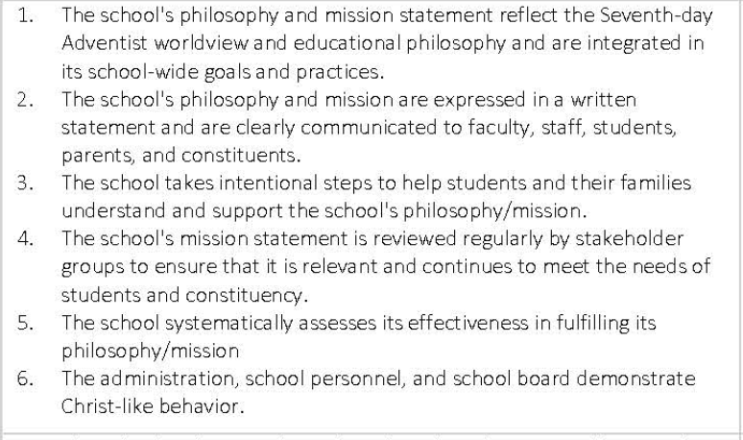

Rating Levels Scores Descriptors

Exceptionally Met  4.0 | Evidences provide strong support for the exceptional implementation of the indicator or standard
Met  3.0 | Evidences provide sufficient support for the implementation of the indicator or standard
Partially Met  2.0 | Evidences provide partial support for the implementation of the indicator or standard
Not Met 1.0 | Evidences provide minimal or no support for the implementation of the indicator or standard

Standard 1:

Indicator #1 | Proposed Rating
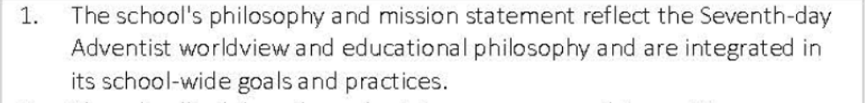
Rationale - Indicator #1 | Proposed Evidence
Indicator #2 | Proposed Rating
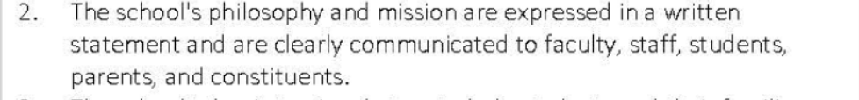
Rationale - Indicator #2 | Proposed Evidence
Indicator #3 | Proposed Rating
Rationale - Indicator #3 | Proposed Evidence
Indicator #4 | Proposed Rating
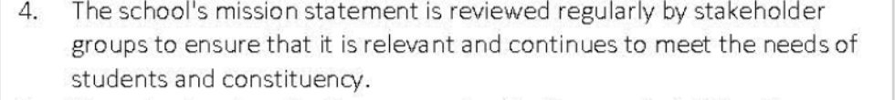
Rationale - Indicator #4 | Proposed Evidence
Indicator #5 | Proposed Rating
Rationale - Indicator #5 | Proposed Evidence
Indicator #6 | Proposed Rating
Rationale - Indicator #6 | Proposed Evidence

