Standard #2: Curriculum
Admin & Staff
Team Lead:

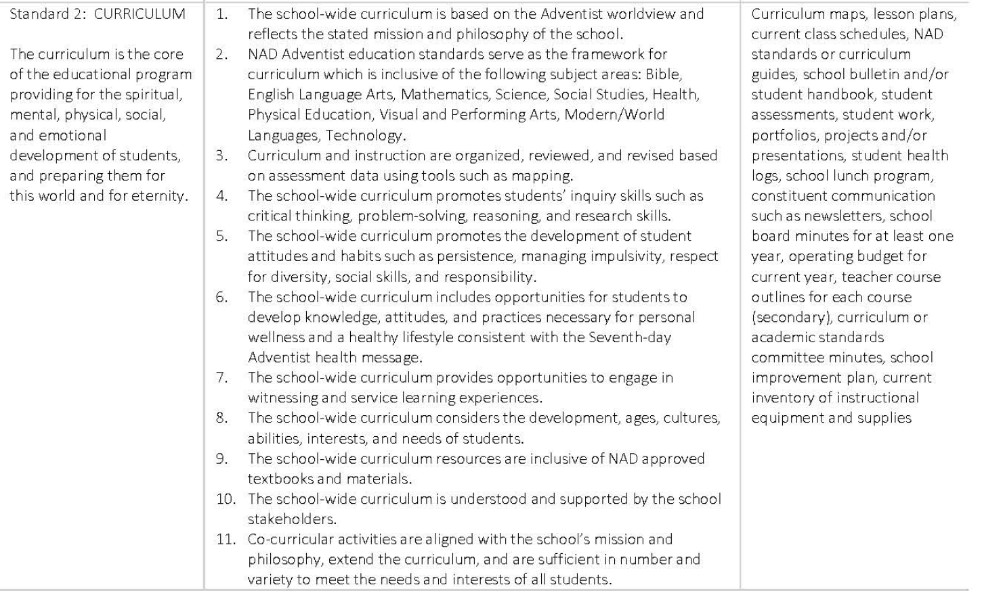

Rating Levels Scores Descriptors

Exceptionally Met  4.0 | Evidences provide strong support for the exceptional implementation of the indicator or standard
Met  3.0 | Evidences provide sufficient support for the implementation of the indicator or standard
Partially Met  2.0 | Evidences provide partial support for the implementation of the indicator or standard
Not Met 1.0 | Evidences provide minimal or no support for the implementation of the indicator or standard

Standard 2:

Indicator #1 | Proposed Rating
Rationale - Indicator #1 | Proposed Evidence
Indicator #2 | Proposed Rating
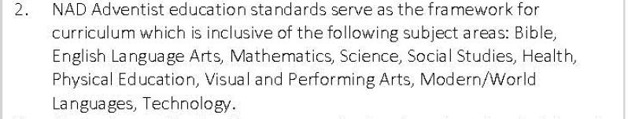
Rationale - Indicator #2 | Proposed Evidence
Indicator #3 | Proposed Rating
Rationale - Indicator #3 | Proposed Evidence
Indicator #4 | Proposed Rating
Rationale - Indicator #4 | Proposed Evidence
Indicator #5 | Proposed Rating
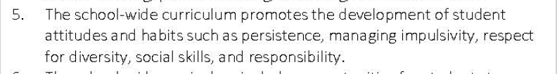
Rationale - Indicator #5 | Proposed Evidence
Indicator #6 | Proposed Rating
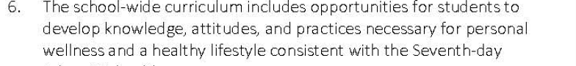
Rationale - Indicator #6 | Proposed Evidence
Indicator #7 | Proposed Rating
Rationale - Indicator #7 | Proposed Evidence
Indicator #8 | Proposed Rating
Rationale - Indicator #8 | Proposed Evidence
Indicator #9 | Proposed Rating
Rationale - Indicator #9 | Proposed Evidence

