Standard #6A: School Environment
(Learning Climate, Information Resources & Technology Integration)
Team Lead:
Team Members:

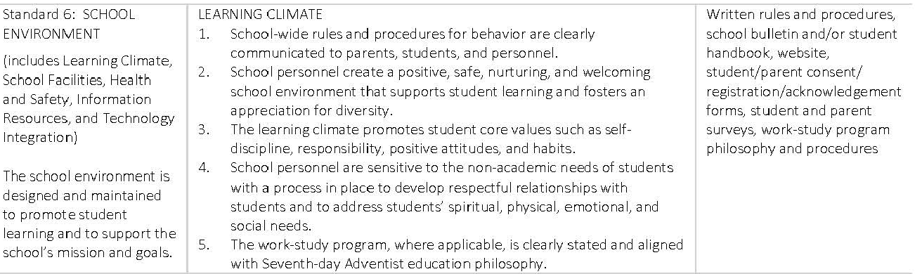
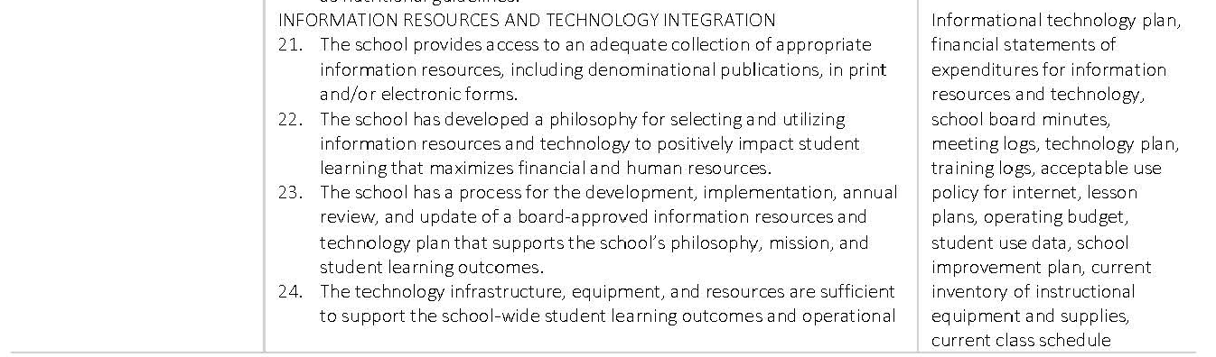
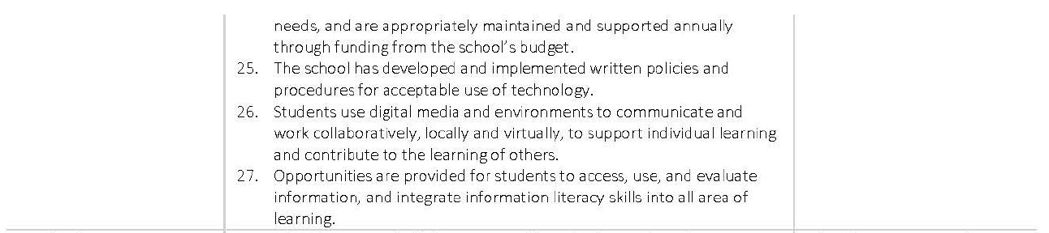
Rating Levels Scores Descriptors

Exceptionally Met  4.0 | Evidences provide strong support for the exceptional implementation of the indicator or standard
Met  3.0 | Evidences provide sufficient support for the implementation of the indicator or standard
Partially Met  2.0 | Evidences provide partial support for the implementation of the indicator or standard
Not Met 1.0 | Evidences provide minimal or no support for the implementation of the indicator or standard

Standard 6: Learning Climate 1-5 & Information Resources & Technology Integration 21-27

Indicator #1 | Proposed Rating
Rationale - Indicator #1 | Proposed Evidence
Indicator #2 | Proposed Rating
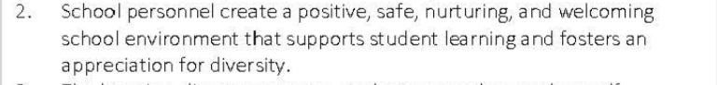
Rationale - Indicator #2 | Proposed Evidence
Indicator #3 | Proposed Rating
Rationale - Indicator #3 | Proposed Evidence
Indicator #4 | Proposed Rating
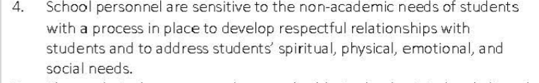
Rationale - Indicator #4 | Proposed Evidence
Indicator #5 | Proposed Rating
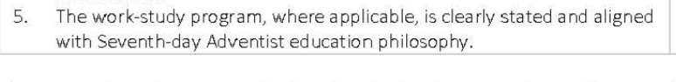
Rationale - Indicator #5 | Proposed Evidence
Indicator #21 | Proposed Rating
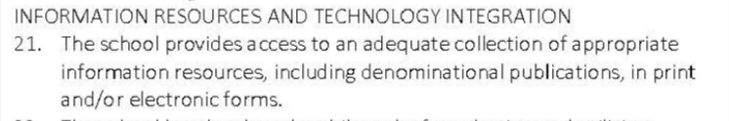
Rationale - Indicator #21 | Proposed Evidence
Indicator #22 | Proposed Rating
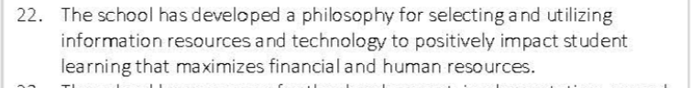
Rationale - Indicator #22 | Proposed Evidence
Indicator #23 | Proposed Rating
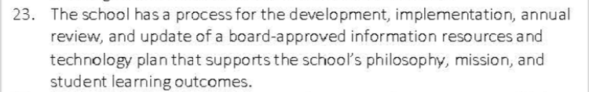
Rationale - Indicator #23 | Proposed Evidence
Indicator #24 | Proposed Rating
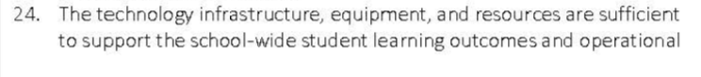
Rationale - Indicator #24 | Proposed Evidence
Indicator #25 | Proposed Rating
Rationale - Indicator #25 | Proposed Evidence
Indicator #26 | Proposed Rating
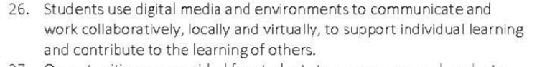
Rationale - Indicator #26 | Proposed Evidence
Indicator #27 | Proposed Rating
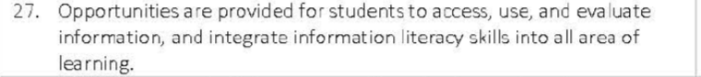
Rationale - Indicator #27 | Proposed Evidence

