Standard #6B: School Environment
(School Facilities, Health & Safety)
Team Lead:
Team Members:

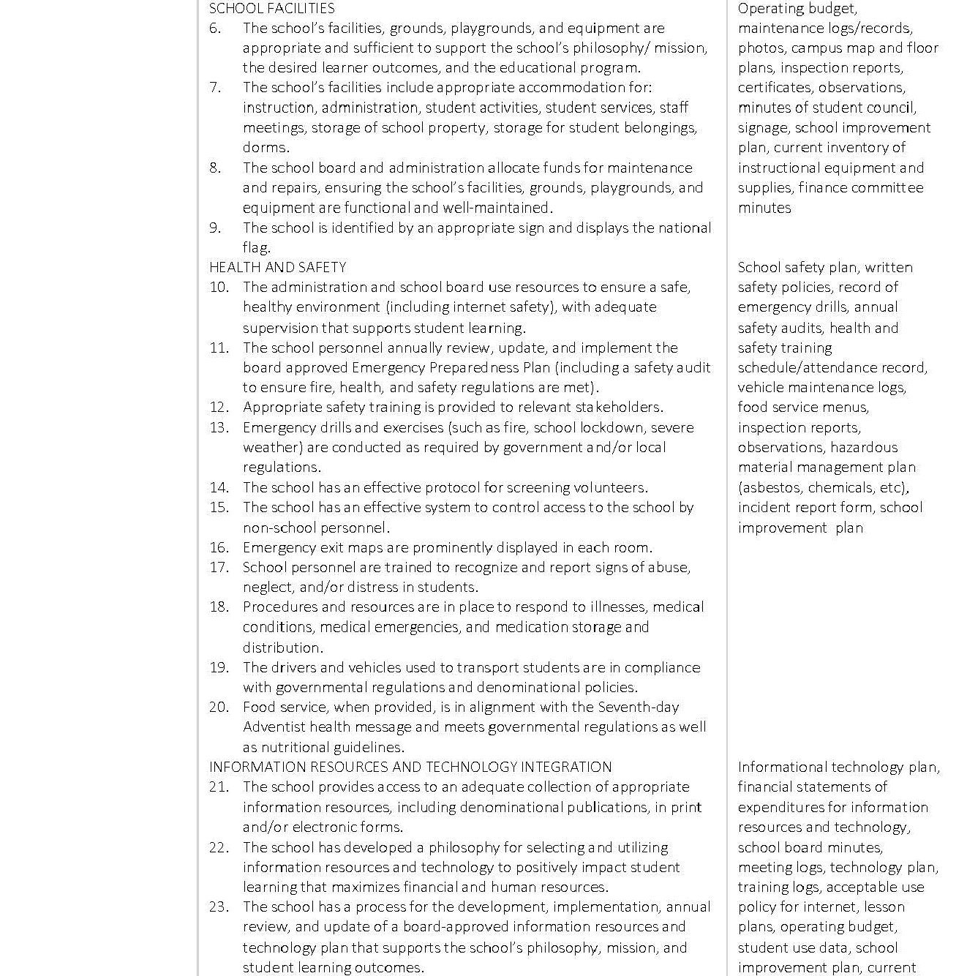

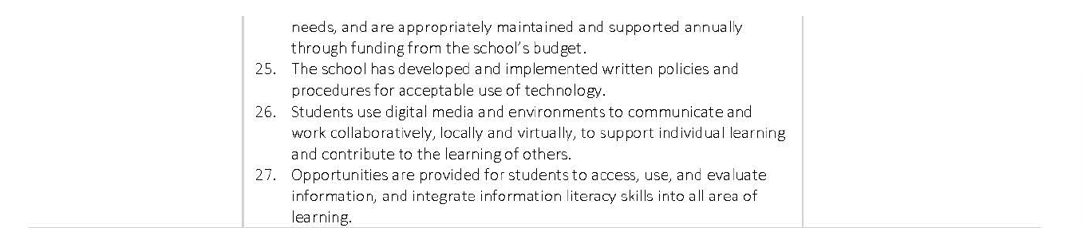

Rating Levels Scores Descriptors

Exceptionally Met  4.0 | Evidences provide strong support for the exceptional implementation of the indicator or standard
Met  3.0 | Evidences provide sufficient support for the implementation of the indicator or standard
Partially Met  2.0 | Evidences provide partial support for the implementation of the indicator or standard
Not Met 1.0 | Evidences provide minimal or no support for the implementation of the indicator or standard

Standard 6: School Facilities & Health & Safety

Indicator #6 | Proposed Rating
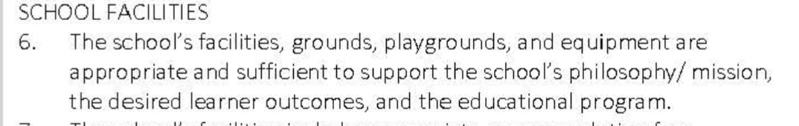
Rationale - Indicator #6 | Proposed Evidence
Indicator #7 | Proposed Rating
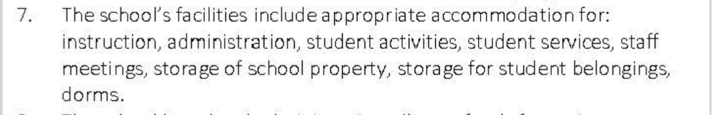
Rationale - Indicator #7 | Proposed Evidence
Indicator #8 | Proposed Rating
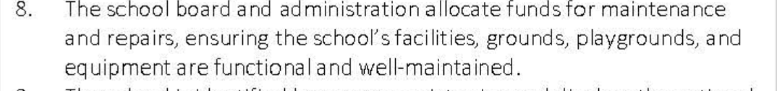
Rationale - Indicator #8 | Proposed Evidence
Indicator #9 | Proposed Rating
Rationale - Indicator #9 | Proposed Evidence
Indicator #10 | Proposed Rating
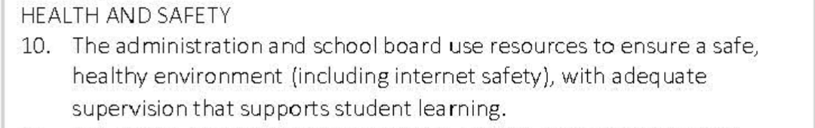
Rationale - Indicator #10 | Proposed Evidence
Indicator #11 | Proposed Rating
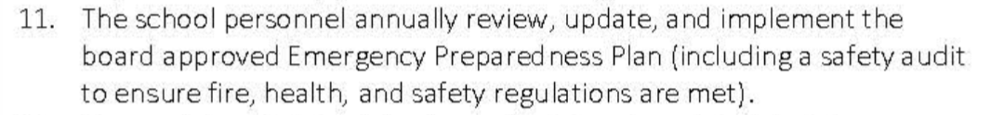
Rationale - Indicator #11 | Proposed Evidence
Indicator #12 | Proposed Rating
Rationale - Indicator #12 | Proposed Evidence
Indicator #13 | Proposed Rating
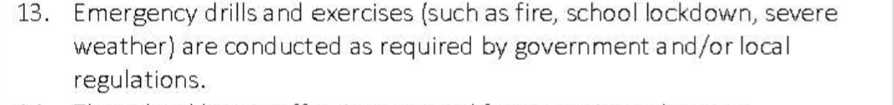
Rationale - Indicator #13 | Proposed Evidence
Indicator #14 | Proposed Rating
Rationale - Indicator #14 | Proposed Evidence
Indicator #15 | Proposed Rating
Rationale - Indicator #15 | Proposed Evidence
Indicator #16 | Proposed Rating
Rationale - Indicator #16 | Proposed Evidence
Indicator #17 | Proposed Rating
Rationale - Indicator #17 | Proposed Evidence
Indicator #18 | Proposed Rating
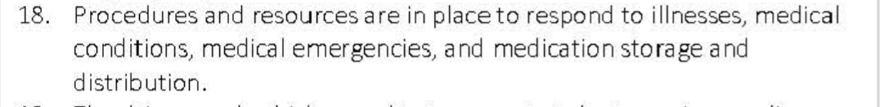
Rationale - Indicator #18 | Proposed Evidence
Indicator #19 | Proposed Rating
Rationale - Indicator #19 | Proposed Evidence
Indicator #20 | Proposed Rating
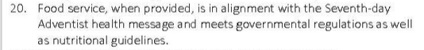
Rationale - Indicator #20 | Proposed Evidence

