Standard #8: Communication & Collaboration
Team Lead:
Team Members:

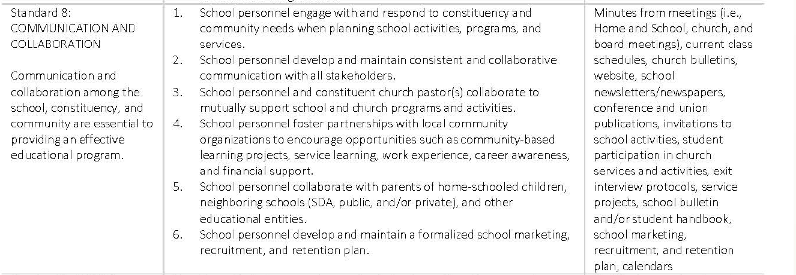

Rating Levels Scores Descriptors

Exceptionally Met  4.0 | Evidences provide strong support for the exceptional implementation of the indicator or standard
Met  3.0 | Evidences provide sufficient support for the implementation of the indicator or standard
Partially Met  2.0 | Evidences provide partial support for the implementation of the indicator or standard
Not Met 1.0 | Evidences provide minimal or no support for the implementation of the indicator or standard

Standard 8: Communication & Collaboration

Indicator #1 | Proposed Rating
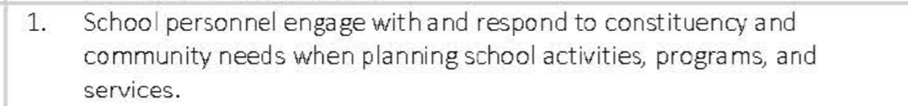
Rationale - Indicator #1 | Proposed Evidence
Indicator #2 | Proposed Rating
Rationale - Indicator #2 | Proposed Evidence
Indicator #3 | Proposed Rating
Rationale - Indicator #3 | Proposed Evidence
Indicator #4 | Proposed Rating
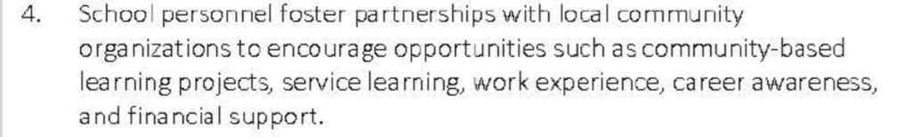
Rationale - Indicator #4 | Proposed Evidence
Indicator #5 | Proposed Rating
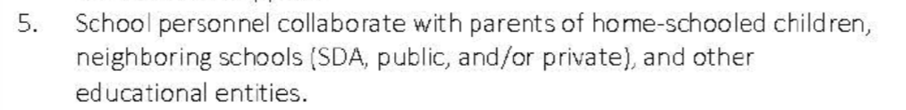
Rationale - Indicator #5 | Proposed Evidence
Indicator #6 | Proposed Rating
Rationale - Indicator #6 | Proposed Evidence

